**Web Programming**

**(LAB Session-06)**

* **Introduction to client-side scripting using JavaScript**

**1.Write a JavaScript code that takes a number as input from user and reversed the number and prints it on browser window. The input number should be last 5 digits of your enrolment number and the JS used in the code should be part of the same HTML page.**

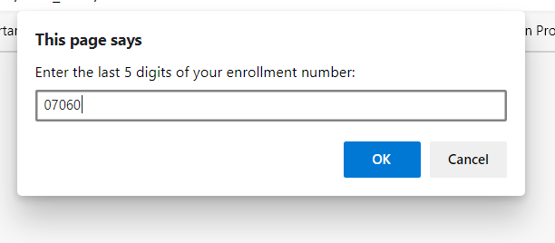

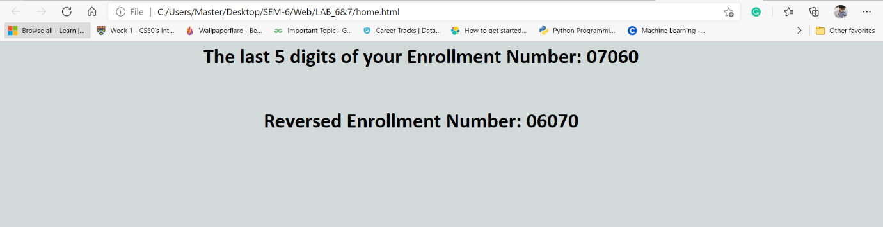

**CODE:**

**<!DOCTYPE html>**

**<html>**

**<head>**

**<title>Lab Session ~ 6</title>**

**</head>**

**<body style="background-color: #D2D9D9 ">**

**<script>**

**var enrollment = prompt("Enter the last 5 digits of your enrollment number: ");**

**document.write("<h1><center>The last 5 digits of your Enrollment Number: "+ enrollment +"</h1></center>");**

**if (enrollment.length > 5 || enrollment.length < 5)**

**{**

**enrollment = prompt("Please, Enter a valid Enrollment Number: ");**

**}**

**var mod = 0, result = 0;**

**for (var i = 0; i < 5; i++)**

**{**

**mod = enrollment%10;**

**result = result*10;**

**result = result+mod;**

**enrollment = Math.floor(enrollment/10);**

**}**

**document.write("<br><center><h1>Reversed Enrollment Number: "+result+"</center></h1>");**

**</script>**

**</body>**

**</html>**

**2.Write a JavaScript program that takes a string as input and checks whether the string is palindrome or not.**

**The JS code should be in the external .js file and output should contain screenshots for below input**

**A) “radar”**

**B) “was it a cat I saw”**

**C) Your Name**

**Your submission should contain source code and output screenshot taken from browser.**

**1)”Radar”**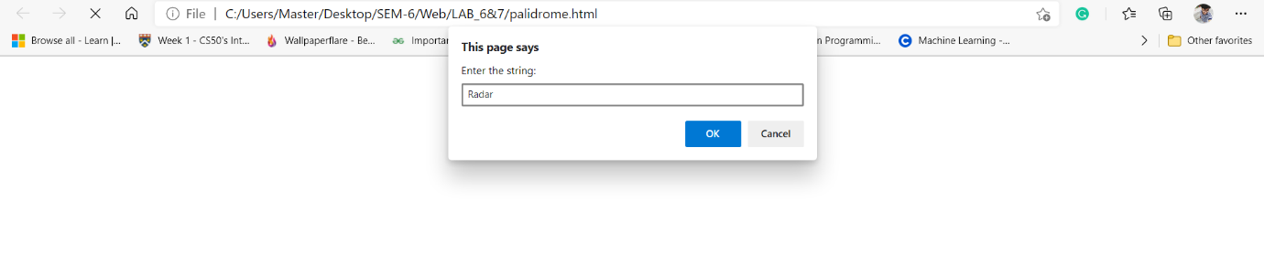

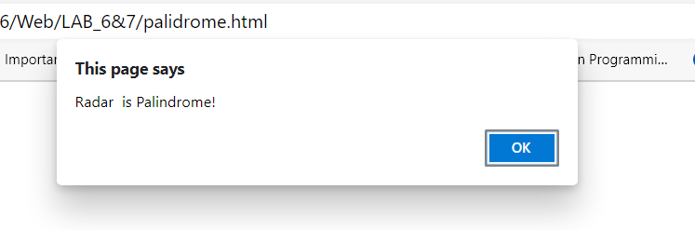

**2) “Was it a cat I saw”**

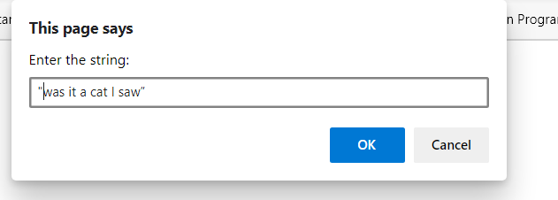

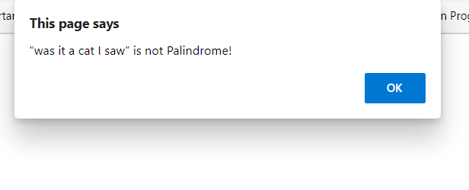

**3) Arjun**

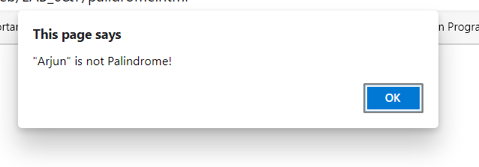

**CODE: Palidrome.html**

**<!DOCTYPE html>**

**<html>**

**<head>**

**<title>Palidrome Check</title>**

**<script type="text/javascript" src="script.js"></script>**

**</head>**

**<body>**

**</body>**

**</html>**

**Script.js**

**var str = prompt("Enter the string: ");**

**str1 = str.split(" ").join("").toLowerCase();**

**var new_str = "";**

**for (let i in str1)**

**{**

**new_str += str1[str.length-i-1]**

**}**

**if (str1 == new_str)**

**{**

**alert(str + " is Palindrome!");**

**}**

**else**

**{**

**alert(str + " is not Palindrome!")**

**}**